**Touch Screen Adaptability: User Calibration based Touch Screen Responsivity**

Project Documentation Submitted

to the Faculty of School of

Computing and Information Technologies

of

Asia Pacific College

In Fulfillment of the Requirements for the subject

Systems Analysis & Detailed Design for CS-SS

by

CORONEL, Sherine Jane

DELA CRUZ, Joey Bernadette

JIMENEZ, Marc Adrian

LLANTOS, Joneil Thom

Table of Contents

[Abstract 3](https://asiapacificcollege.sharepoint.com/sites/ThomasandFriends/Shared%20Documents/General/Documentation/Touch-CSFormat.docx#_Toc489874991)

[List of Figures, List of Tables, List of Notations 4](https://asiapacificcollege.sharepoint.com/sites/ThomasandFriends/Shared%20Documents/General/Documentation/Touch-CSFormat.docx#_Toc489874992)

[I. Introduction 5](https://asiapacificcollege.sharepoint.com/sites/ThomasandFriends/Shared%20Documents/General/Documentation/Touch-CSFormat.docx#_Toc489874993)

[1.1. Project Context 5](https://asiapacificcollege.sharepoint.com/sites/ThomasandFriends/Shared%20Documents/General/Documentation/Touch-CSFormat.docx#_Toc489874994)

[1.1.1. The Challenges 5](https://asiapacificcollege.sharepoint.com/sites/ThomasandFriends/Shared%20Documents/General/Documentation/Touch-CSFormat.docx#_Toc489874995)

[1.1.2. The Opportunity 5](https://asiapacificcollege.sharepoint.com/sites/ThomasandFriends/Shared%20Documents/General/Documentation/Touch-CSFormat.docx#_Toc489874996)

[1.1.3. Purpose and Description 5](https://asiapacificcollege.sharepoint.com/sites/ThomasandFriends/Shared%20Documents/General/Documentation/Touch-CSFormat.docx#_Toc489874997)

[1.1.4. Background of the Problem 5](https://asiapacificcollege.sharepoint.com/sites/ThomasandFriends/Shared%20Documents/General/Documentation/Touch-CSFormat.docx#_Toc489874998)

[1.2. Objectives 7](https://asiapacificcollege.sharepoint.com/sites/ThomasandFriends/Shared%20Documents/General/Documentation/Touch-CSFormat.docx#_Toc489874999)

[1.3. Scope and Limitation 8](https://asiapacificcollege.sharepoint.com/sites/ThomasandFriends/Shared%20Documents/General/Documentation/Touch-CSFormat.docx#_Toc489875000)

[II. Literature Review 9](https://asiapacificcollege.sharepoint.com/sites/ThomasandFriends/Shared%20Documents/General/Documentation/Touch-CSFormat.docx#_Toc489875001)

[2.1. Smartphone Usage 9](https://asiapacificcollege.sharepoint.com/sites/ThomasandFriends/Shared%20Documents/General/Documentation/Touch-CSFormat.docx#_Toc489875003)

[2.2. Touch Calibration 9](https://asiapacificcollege.sharepoint.com/sites/ThomasandFriends/Shared%20Documents/General/Documentation/Touch-CSFormat.docx#_Toc489875004)

[2.3. Virtual Keyboard 9](https://asiapacificcollege.sharepoint.com/sites/ThomasandFriends/Shared%20Documents/General/Documentation/Touch-CSFormat.docx#_Toc489875009)

[2.4. Usability Testing 9](https://asiapacificcollege.sharepoint.com/sites/ThomasandFriends/Shared%20Documents/General/Documentation/Touch-CSFormat.docx#_Toc489875010)

[III. Technical Background 10](https://asiapacificcollege.sharepoint.com/sites/ThomasandFriends/Shared%20Documents/General/Documentation/Touch-CSFormat.docx#_Toc489875011)

[5.1. Theoretical Framework 10](https://asiapacificcollege.sharepoint.com/sites/ThomasandFriends/Shared%20Documents/General/Documentation/Touch-CSFormat.docx#_Toc489875015)

[5.1.1. Access Control 10](https://asiapacificcollege.sharepoint.com/sites/ThomasandFriends/Shared%20Documents/General/Documentation/Touch-CSFormat.docx#_Toc489875016)

[5.1.2. Biometric Authentication 10](https://asiapacificcollege.sharepoint.com/sites/ThomasandFriends/Shared%20Documents/General/Documentation/Touch-CSFormat.docx#_Toc489875017)

[5.1.3. Juels and Sudans Fuzzy Vault Scheme 11](https://asiapacificcollege.sharepoint.com/sites/ThomasandFriends/Shared%20Documents/General/Documentation/Touch-CSFormat.docx#_Toc489875018)

[5.1.4. Capacitive Scanner 12](https://asiapacificcollege.sharepoint.com/sites/ThomasandFriends/Shared%20Documents/General/Documentation/Touch-CSFormat.docx#_Toc489875019)

[5.2. Conceptual Framework 13](https://asiapacificcollege.sharepoint.com/sites/ThomasandFriends/Shared%20Documents/General/Documentation/Touch-CSFormat.docx#_Toc489875020)

[5.3. Definition of Terms 13](https://asiapacificcollege.sharepoint.com/sites/ThomasandFriends/Shared%20Documents/General/Documentation/Touch-CSFormat.docx#_Toc489875021)

[IV. Design and Methodology 14](https://asiapacificcollege.sharepoint.com/sites/ThomasandFriends/Shared%20Documents/General/Documentation/Touch-CSFormat.docx#_Toc489875022)

[6.1. Nature of Study 14](https://asiapacificcollege.sharepoint.com/sites/ThomasandFriends/Shared%20Documents/General/Documentation/Touch-CSFormat.docx#_Toc489875024)

[6.2. Sampling Technique 14](https://asiapacificcollege.sharepoint.com/sites/ThomasandFriends/Shared%20Documents/General/Documentation/Touch-CSFormat.docx#_Toc489875025)

[6.3. Population and Sample 14](https://asiapacificcollege.sharepoint.com/sites/ThomasandFriends/Shared%20Documents/General/Documentation/Touch-CSFormat.docx#_Toc489875026)

[6.4. Research Instruments 14](https://asiapacificcollege.sharepoint.com/sites/ThomasandFriends/Shared%20Documents/General/Documentation/Touch-CSFormat.docx#_Toc489875027)

[6.5. Gathering Procedures 15](https://asiapacificcollege.sharepoint.com/sites/ThomasandFriends/Shared%20Documents/General/Documentation/Touch-CSFormat.docx#_Toc489875028)

[6.6. Data analysis 15](https://asiapacificcollege.sharepoint.com/sites/ThomasandFriends/Shared%20Documents/General/Documentation/Touch-CSFormat.docx#_Toc489875029)

[V. Appendices 17](https://asiapacificcollege.sharepoint.com/sites/ThomasandFriends/Shared%20Documents/General/Documentation/Touch-CSFormat.docx#_Toc489875030)

[7.1. Bibliography 17](https://asiapacificcollege.sharepoint.com/sites/ThomasandFriends/Shared%20Documents/General/Documentation/Touch-CSFormat.docx#_Toc489875032)

[7.2. Evaluation Tool or Test Document 19](https://asiapacificcollege.sharepoint.com/sites/ThomasandFriends/Shared%20Documents/General/Documentation/Touch-CSFormat.docx#_Toc489875033)

[7.2.1. Hyperhidrosis Scale 19](https://asiapacificcollege.sharepoint.com/sites/ThomasandFriends/Shared%20Documents/General/Documentation/Touch-CSFormat.docx#_Toc489875034)

Abstract

The versatillity and functionality of touch screen is highly commended by researchers, as it is an absolute coordinate system wherein a point is selected directly as opposed to relative positioning systems such as a mouse. However, due to software and hardware incompatibilities, inaccuracies and flaws exists in the system,

The proponents will investigate the main cause of inaccuracies and inefficiencies with regards to the touch registers, and will propose a solution for smartphone manufacturers for them to solve the said issue.

More than 5% of the world's population (approximately 367 Million people) are affected by hyperhidrosis. Hyperhidrosis is a condition where a person experiences excessive and uncontrollable sweating. Most smartphones have capacitive touch screens, on top of that, in order to register "touches", a circuit has to be completed through conductive means. Fingers are conductive and so is sweat, therefore, sweat droplets can register touches in the smartphone, making it difficult for a palmar hyperhidrosis patient to register accurate "touches" in his smart phone. This study aims to study the human computer interaction between smartphone and palmar hyperhidrosis patient. The proponents will investigate and propose a solution for smartphone manufacturers on the problems and struggles encountered by a palmar hyperhidrosis patient when using the touch sensitive display and fingerprint authentication features of his smartphone.

List of Figures, List of Tables, List of Notations

[Figure 1 Biometric Authentication Process 13](https://asiapacificcollege-my.sharepoint.com/personal/mpjimenez_student_apc_edu_ph/Documents/INTSDEV/Biometrics-CSFormat.docx#_Toc479542703)

[Figure 2 Capacitive Scanner Technology 14](https://asiapacificcollege-my.sharepoint.com/personal/mpjimenez_student_apc_edu_ph/Documents/INTSDEV/Biometrics-CSFormat.docx#_Toc479542704)

[Figure 3 Biometric Authentication Process 15](https://asiapacificcollege-my.sharepoint.com/personal/mpjimenez_student_apc_edu_ph/Documents/INTSDEV/Biometrics-CSFormat.docx#_Toc479542705)

1. Introduction
   1. Project Context
      1. The Challenges

The touch registers of touchscreen smartphones in the market is highly dependable on the user; screen size must scale to the users’ hand size to reach more accurate registers. Varying factors also exists not only in the hardware part, but also in the software part as the touch responsiveness also varies depending on the current running operating system.

* + 1. The Opportunity

This research can help smartphone manufacturers on improving their devices by increasing the satisfaction experienced by their customers through the custom-calibrated touch registers.

* + 1. Purpose and Description

This research serves as a possible solution for smartphone manufacturers to increase the consumer satisfaction rate of their products. This research aims to develop an android application that will calibrate the touch screen registering algorithms depending on the user to further increase accuracy and precision of future touch registers; after performing different evaluating tests. Also, this research aims to know the causes of the malfunctions and the inaccuracies of android touch registers; especially in using virtual keyboards.

* + 1. Background of the Problem

Smartphones are hand held devices that functions like a computer. They can receive and make calls, create and receive messages. Also, these smartphones have the capability to connect to the internet, making them capable of downloading and running 3rd party apps (downloaded from digital distribution platforms such as Google Play and App Store). Smartphones were first introduced in 1999 by the Japanese company NTT DoCoMo and became widespread a year after. A lot of firms have been competing in the Smartphone Industry and the competition never stops, for every year, new features and innovations are being introduced.

Touch screen based smartphones has been constantly developing throughout the years and has proven reliability. This technology is a type of visual display, it enables the users to interact with an electronic device by touch. Touch screen technology also opened new possibilities for the security aspects of smartphones.

Touch screen added dynamics and enabled development of many applications. The utilization of touch screen jump from mobile devices to life size monitors. Smartphones, gaming consoles, Automatic Teller Machines (ATM), Point of Sales (POS), and digital signage’s using touch screen is rampantly visible in our daily lives. As compared to other human machine interfaces, touch screens have various advantages as opposed to physical such as the reduction of physical requirements to deploy it, also the maintenance that comes with the use of it.

Last year, 2016, new features came up such as fingerprint authentication, and water and dust resistance. Fingerprint authentication revolutionized security, while water and dust resistance dramatically enhanced durability. Fingerprint authentication is a type of biometric authentication where the user registers his fingerprint in his smartphone. It can be used in the future to easily unlock his device; the registered fingerprint can also unlock certain applications and may be used to verify virtual transactions.

The fingerprint authentication functions through storing a photograph of how the user’s fingerprint looks. Though when the user’s finger is wet, the sensor can’t match the current authentication to the stored fingerprint. This situation usually occurs when the user’s hand is sweaty and oily.

The same condition also affects touch registers in touch screens; a thin layer of oil or other debris touching the screen can sometimes be registered as touch, and can also mislead the system in reading multi-touches. The developers of Android didn’t overlook this, they made in-OS touch diagnostic measures, by typing “*#0*#”, a compilation of system diagnostic measures is listed, and one of them is the touch diagnosis wherein there are boxes and the user should go through and touch the boxes and they box will be filled with a color signifying a recorded touch.

Developers have been attempting to move past this flaw and developed various keyboard applications and marketed that their keyboard makes typing more efficient, and will make typing more precise.

* 1. Objectives

This research aims improve the user experience in touch screen smartphones; increasing accuracy and precision of touch registers made by the user in his smartphone by prompting an initial calibration (and also if the user deemed necessary; re-calibration). The results of the initial calibration will alter and prompt the system to adapt depending on the said results gathered from the user. Thus, the objectives are…

1. To increase user satisfaction upon product consumption; to help the system satisfy the varying users when it comes to the touch screen display.

2. To produce a touch calibrating software wherein the system will adapt on the users usage, increasing touch accuracy and precision.

3. To determine the causes of the inaccuracy of touch registers on a touch screen smartphone.

* 1. Scope and Limitation

This study focuses on the causes of the inefficiencies and inaccuracies of smartphone touch registers. Due to the extremities of resources, this research will only be focusing on Android OS devices.

1. Literature Review
2. 1. Smartphone Usage

The existence of smartphones indeed made daily lives easier, with the dynamic functionalities that it can give; utilization of mass-communication, entertainment, and security. According to pawnhero.ph, the Philippines is the third largest and fastest growing market for smartphones in South East Asia with the first being Indonesia.

* 1. Touch Calibration

The higher number of A/D converter bits, the higher touch screen accuracy. However, Liquid Crystal Displays (LCD) doesn’t necessarily need high levels of A/D bits. A/D resolution is computed as N = 2M where M = number of bits; therefore, for a 1920x1080 display, a 11-bit A/D converter is already sufficient. Resistive touch screens required frequent calibration as parameters constantly change. The two main factors affecting the touch screen and LCD as stated by Ping-yong and Zhong-wen are the errors in rotation and translation that was introduced upon the installation of the touch screen to the LCD, and the fact that the touch screen and LCD are two different physical aspects. Mechanical errors in touchscreen are generated upon installation of touch screen on the LCD, this includes displacement errors and rotation errors (Ping-yong & Zhong-wen, 2014). They proposed a five-point/multi-point calibration algorithm, which is divided into six parts: Initialization, Screen Display, Access of Coordinates, Calculation of Calibration Coefficient, Deviation Correction, Storage of Calibration Coefficient.

2. 3. Virtual Keyboard

In contrary to the researchers’ beliefs, --- concluded that device size has no direct correlation to the inaccuracy of touch registers, rather the strongest factors affecting it is the devices’ form factor and the devices’ user group.

* 1. Usability Testing

According to the study conducted by Paul, H.P. Yeow and Vimala Balakrishnan, …… Upon further investigation on the effect of the varying thumb sizes in text messaging,

Upon the birth of a new smartphone software, there are two types of testing environments used for the testing and evaluation of the touchscreen responsiveness, which is according to (GLAVINIC ET AL) is using the mobile device itself and the other testing environment is virtual, with the help of emulators and touch sensitive monitors. Usability issues in certain activities such as the virtual keyboard usage, dragging gestures, visual search and selection arises in touch screen devices. The Touchscreen Usability Meta-Test, proposed by Glavinic, Ljubic, & Kukec focuses on measuring the user performance in numerical figures of errors and time completion of a certain action. It consists of 5 test scenarios, namely *1 – Target Size*, *2 – Object Search*, *3 -Boundary Objects*, *4 – Drag&Drop*, and lastly, *5 – Soft Keystroking*. While performing these test scenarios, the user interaction with the software is logged, that the system will process in order to calculate performance time, identify errors, and determine the users’ behavior.

1. Technical Background
2. 1. Theoretical Framework
      1. Access Control

Access Control is the ability of one place or resource to limit access through different media, such as PINs, passwords, biometric scans, etc. Access control runs on comparing data from the database with the current input, scanning for a pair that matches the current input. Access control works at different levels in a system. Access control working at the Application level is based on the users roles, some features are available to higher level roles, and are restricted to those below them. Applications can be written on top of middleware, access control working at the Middleware level is ensures a certain process, usually used in database management systems. Middleware uses facilities provided by the operating system, access control working at the operating system level provides basic security for files and ports. Lastly, the operating system heavily relies on the hardware, access control working at the hardware level controls the memory addresses process can access.

* + 1. Biometric Authentication

Biometric authentication is the process in which physical characteristics are used to validate identity, making it hard to fake and tamper as these attributes are unique to one person only. Physiological characteristics are used in order to authenticate access such as Fingerprints, Palm prints, DNA, iris recognition, etc. The wide use of biometric authentication in the community heavily increased the level of security one device or facility has.

Biometric system can be used in two modes. The first one is the identity verification which occurs when the identity of the user is already enrolled in the system (Has an ID card or login name). The biometric data that is gathered from the user is compared to the user's data that is already stored in the database. The second mode which is the Identification, or also known as search, occurs when the identity of the user is priori unknown. In this mode, the biometric data of the user is compared to all the records in the database, even though the user does not have data stored in the database. It is noticeable that the second mode is more challenging and costly.

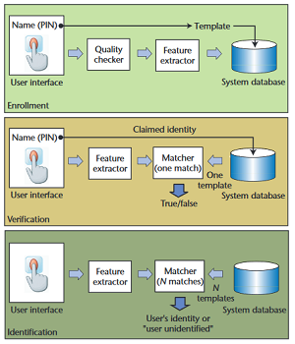 Fingerprint scanners needs to fulfill 2 jobs, getting the image of the finger, compares the ridges and valleys of a fingerprint with existing fingerprints. Only unique characteristics are recorded and encrypted. The unique characteristics are then converted into a binary code, and is stored in a database, which are then used to validate entries.

Figure 1 Biometric Authentication Process

* + 1. Juels and Sudans Fuzzy Vault Scheme

Fuzzy Vault is an encryption scheme, stating that in order to encode an information, a key is required to decode it with ease. Its concept revolves around the idea that “A secret is encoded using a set values (the key), and can then be unlocked with another set of values if it has fairly large resemblance with set used to lock it”. The Fuzzy Vault is often used with Reed-Solomon codes also known as error-correcting codes. 2 algorithms are used in the fuzzy vault scheme, LOCK and UNLOCK.

* + 1. Capacitive Scanner

Fuzzy Capacitive scanner depicts a picture of friction ridges of a person’s finger through the use of electrical currents. Its sensors are made of semiconductor chips which have arrays of incredibly small cells and each cells of it have a couple of conductor plates protected by an insulating layer. The sensor is attached to an electrical circuit wrapped around an inverting operational amplifier which is basically an integrator. Integrators are complex semiconductor device that performs the mathematical operations.

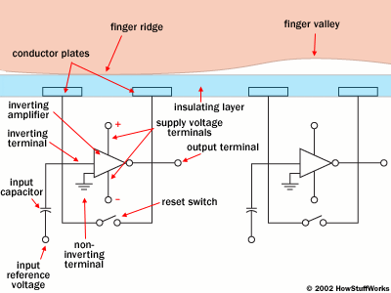 In order to scan you must have the switch shut first in order to gain neutrality to the integrator circuit, and when it is enabled again, the processor will apply a constant charge to the integrator circuit to have the capacitors charged up. The stored electric charge of the feedback loop’s capacitator influences the voltage at the amplifier’s input which then affects the amplifier output. Afterwards, the scanner processor scrutinizes the voltage of each cell to put together a complete image of the fingerprint.

Figure 2 Capacitive Scanner Technology

* 1. Conceptual Framework

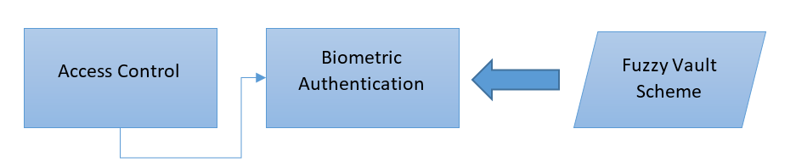 Access Control is the limiting of entry from a certain place or resource, and one type of access control technology is biometric authentication. Biometric Authentication is the process wherein physiological attributes are used in order to validate identity. Some of the algorithms used in Biometric Authentication is the Fuzzy Vault Scheme, objects are compared and the state will only change to unlock if there are a lot of resemblance between those two objects.

Figure 3 Biometric Authentication Process

* 1. Definition of Terms
* ITO (Indium-Tin-Oxide) – electrically conductive material used in touchscreens.

1. Design and Methodology
2. 1. Nature of Study

The researchers are creating a goal-oriented research, focusing on representation to understand the effects of Palmar Hyperhidrosis to the UX when using a smartphone deeply. Under goal-based research, there are two types, representation and generalization. The researchers are using representation, an in-depth understanding of a certain phenomenon, understanding how factors affect a situation, in our case, the factor is the medical condition Palmar Hyperhidrosis and the situation is the user experience when using a smartphone.

* 1. Sampling Technique

The researchers are using snowball sampling to acquire the sample of the research under discussion. This method is also known as referral sampling, which belongs to the category of non-probability sampling technique, is where research participants refer several people who qualifies to take part for a study, or directly recruits them to ease data collection. (Steven Venette, 2013).

* 1. Population and Sample

The population of interest for this study are individuals residing in Metro Manila that owns a smartphone and experiences Palmar Hyperhidrosis.

* 1. Research Instruments

The researchers are using questionnaires, semi-structured interviews, and Iodine-Starch test to gather data from the respondents. Two forms of questionnaire are used, a written and an online-based via Google Forms. The questionnaires for this study is intended to obtain information from several individuals in a short period and to quantify easily by either the researchers or through software packages. Also, semi-structured interviews will be used since they involve personal and direct contact between interviewers and interviewees. However, there are risks that the conversation might digress from the stated research aims and objective. (Gill & Johnson, 2002). For the purposes of this research, Iodine-Starch test will be used to know the rate of sweating in certain areas of their hands.

To further support the statements of this research, other materials are used such as EBSCO Host and Google Scholar for factual references.

* 1. Gathering Procedures

The researchers are providing two questionnaires to the participants, one for the diagnosis of palmar hyperhidrosis and another one for the user experience regarding their smartphone usage given their condition. The researchers are choosing a fraction to do the Iodine-Starch test to determine the severity of sweating in their hands. This procedure also enabled the researcher to conduct interview at the same time consecutively.

* 1. Data Analysis

TOUCH PANNING LATENCY

The formulas that the researchers are using are based on the study of Steven M. Keller, et al. entitled "Diagnosis of palmar hyperhidrosis via questionnaire without physical examination". Formulas that are included in the study for analyzing data are the Mean, Standard Deviation of the Mean, and the Standard Error of the Mean. Mean is to average the number of people with severe cases of Palmar Hyperhidrosis. The Standard Deviation of the mean and Standard Error of the mean are for the accuracy of the data. Standard Deviation is used to see how far the values are from one another, while the Standard Error is the standard deviation of the sampling distribution of a statistic.

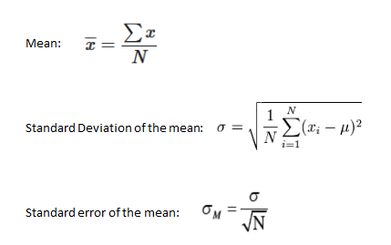

1. UML Diagrams\
   1. Use Case Full Description
   2. 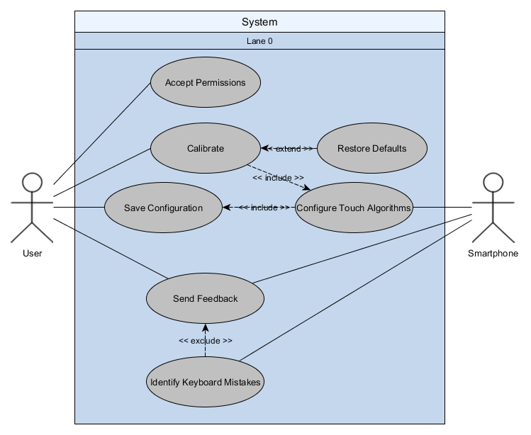Use Case Diagram
   3. 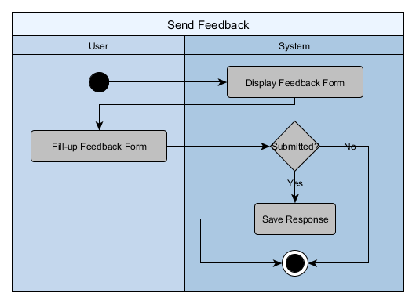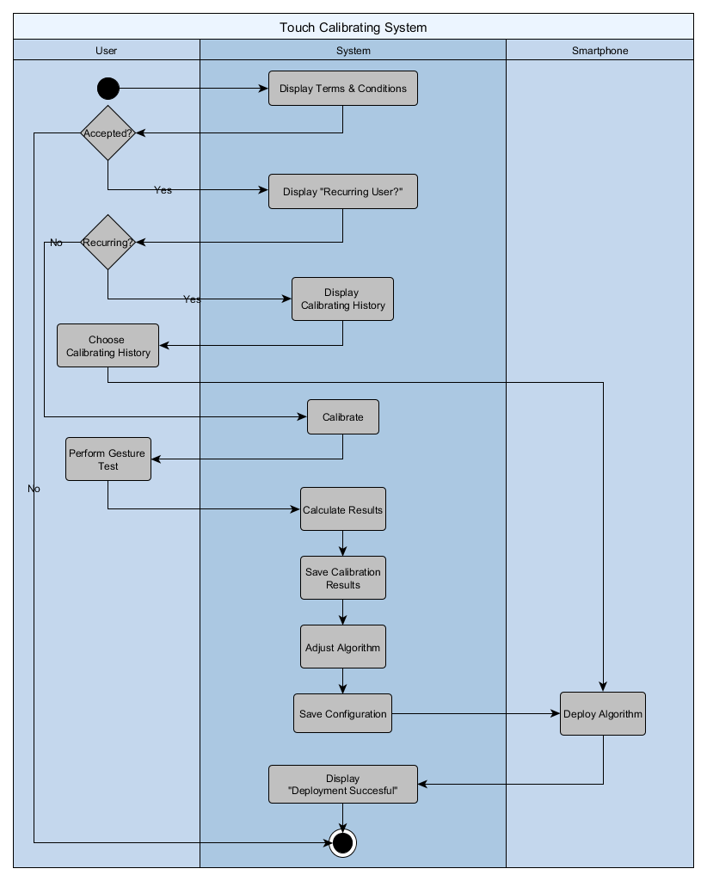Activity Diagram
   4. Object Diagram
   5. Deployment Diagram
   6. Sequence Diagram
   7. Communication Diagram
   8. State Diagram
   9. Timing Diagram
   10. Class Diagram
   11. Component Diagram
   12. Package Diagram
   13. Composite Structure
   14. Interaction Overview
2. Appendices

* 1. Bibliography

Anderson, R. J. (2001). Chapter 4 - Access Control. In R. J. Anderson, *Security Engineering - A Guide to Building Dependable Distributed Systems.* Wiley .

Aramay, R. (n.d.). *Academia.edu.* Retrieved from Chapter 3 Research and Methodology: http://www.academia.edu/7729576/Chapter_3_RESEARCH_AND_METHODOLOGY

Crawley, J. (2015, November 25). *HCI And The Impact On Smartphones*. Retrieved from HCI And The Impact On Smartphones: http://hciandsmartphones.blogspot.com/?view=classic

Enstitutsu, D. B. (n.d.). Biometric Security Technologies. Retrieved from http://ai.pku.edu.cn/aiwebsite/research.files/collected%20papers%20-%20introduction/biometric%20security%20technologies.pdf

Griffin, A. (2016, June 9). *iPhone fingerprint sensor problems like wet fingers can be overcome by adding more fingerprints.* Retrieved from Independent.co.uk: http://www.independent.co.uk/life-style/gadgets-and-tech/news/iphone-fingerprint-sensor-problems-like-wet-fingers-can-be-overcome-by-adding-more-fingerprints-a7072281.html

Harth, W., Gieler, U., Kusnir, D., & Tausk, F. (2008). *Clinical Management in Psychodermatology.* Springer.

Hölzle, E. (2002). Pathophysiology of Sweating. In R. Böni, & G. Burg, *Hyperhidrosis and Botulinum Toxin in Dermatology* (p. 13).

Juels, A., & Sudan, M. (2002). *A Fuzzy Vault Scheme.* Retrieved from http://madhu.seas.harvard.edu/papers/2002/ari-journ.pdf

Mühendisligi Ensitusu, D. B. (n.d.). Biometric Security Technologies.

myVMC. (2015, July 21). *Living with Hyperhidrosis (Excessive Sweating)*. Retrieved from myVMC - Virtual Medical Centre: https://www.myvmc.com/lifestyles/living-with-hyperhidrosis-excessive-sweating/

Poole, E. (2013, Dcember 3). *HCI and mobile health interventions*. Retrieved from NCBI National Institute of Health: https://www.ncbi.nlm.nih.gov/pmc/articles/PMC3830022/

Swartling, C., Brismar, K., Aquilonius, S.-M., Naver, H., Rystedt, A., & Rosell, K. (2011). "Hyperhidros - det "tysta" handikappet. *läkartidningen nr 47 2011 volym 108*.

*The New York Times*. (2013, May 21). Retrieved from The New York Times: http://www.nytimes.com/health/guides/disease/hyperhidrosis/overview.html

Vary, J. J. (2015). Selected Disorders of Skin Appendages--Acne, Alopecia, Hyperhidrosis.

Versace, C. (2013, August 21). *What Do Consumers Want In A New Smartphone?* Retrieved from Forbes: https://www.forbes.com/sites/chrisversace/2013/08/21/what-do-consumers-want-in-a-new-smartphone/#6e4123232ee8

Wolosker, N., Yazbek, G., Milanez de Campos, J. R., Munia, M. A., Kauffman, P., Jatene, F. B., & Puech-Leao, P. (2010). Quality of life before surgery is a predictive factor for satisfaction among patients undergoing sympathectomy to treat hyperhidrosis. Sao Paulo, Brazil: Society of Vascular Surgery.